

University of Petroleum &

Energy Studies

# SCHOOL OF COMPUTER SCIENCE

**Name**: Akshat Agarwal **Course**: BTech CSE **SAP ID**: 500118953

**BATCH**: 1

**PRESENTED TO**: Dr. Syed Sajid Hussain

**Semester**: 3

# Experiment 15: To understand the concepts of implicit and explicit cursor.

**Objective:** Students will be able to implement the concept of implicit and explicit cursor.

1. **Using implicit cursor update the salary by an increase of 10% for all the records in EMPLOYEES table, and finally display how many records have been updated. If no records exist display the message “No Change”.**

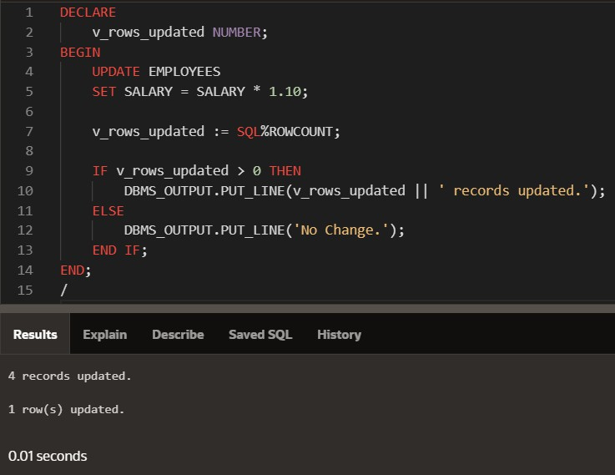

1. **Using explicit cursor fetch the employee name, employee_id and salary of all the records from EMPLOYEES table.**

## INPUT:

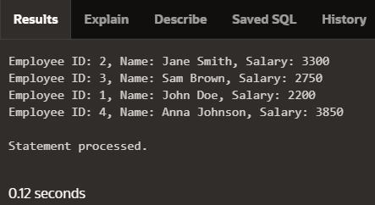

1. **Using explicit cursor Insert the records from EMPLOYEES table for the columns employee_id, Last_Name and salary for those records whose salary exceeds 2500 into a new table TEMP_EMP.**

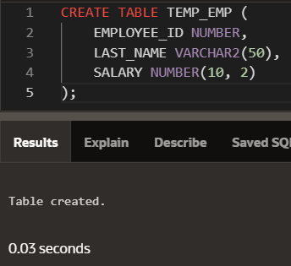Creating TEMP_EMP table:

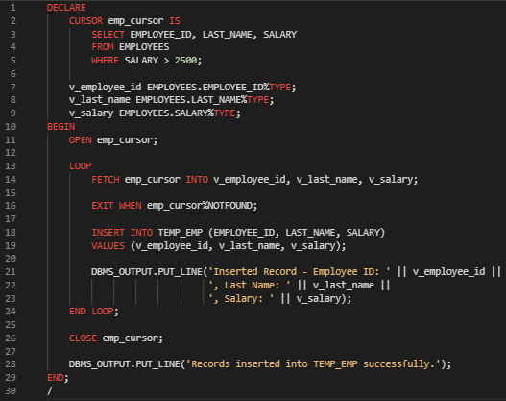**INPUT:**

